OS Lab Report – Week 10 & 11

Memory Management Problems

PES1201800366

Aditeya Baral

**1. Week 10**

Write a C program to implement paging using Best-fit algorithm.

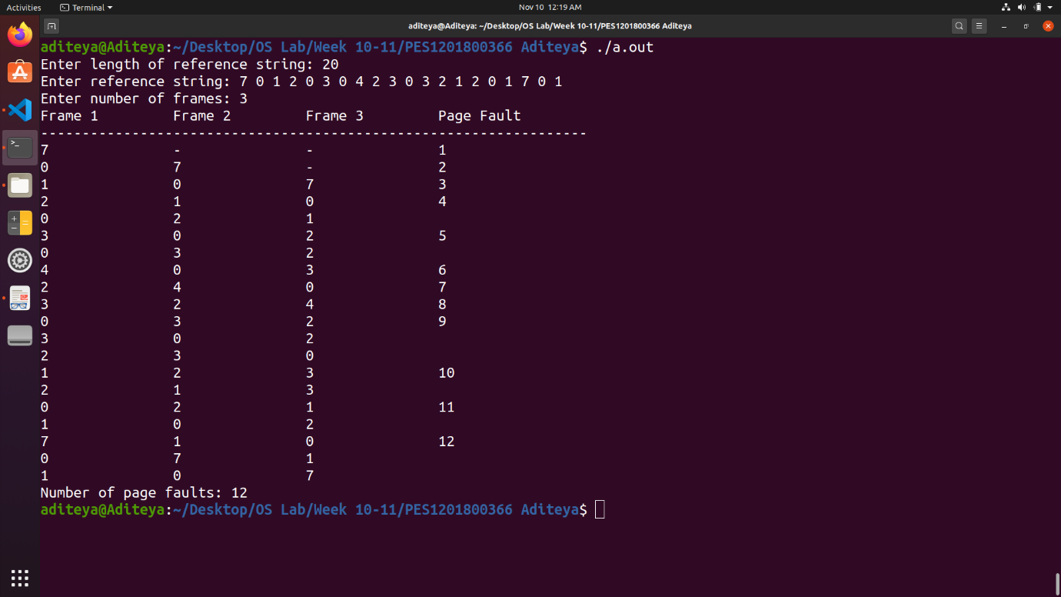

**2. Week 11**

Write a C program to implement Least Recently Used page replacement (LRU) algorithm.

